Computer

Graphics

Submitted To: - Submitted By:-

A.P = Harpal Kaur vikramjit singh

BCA 6th sem

BCA/14/378

Q 1.What are the two types of projections?

Ans. Projection can be defined as a mapping of 3-D object onto 2-D viewing screen. Here 2-D screen is known as plane of projection or view plane which constitutes the display surface. The mapping is determined by projection rats called the projection. Geometric projection of objects is formed by the intersection of lines (called projection) with a plane called plane of projection/view plane. Projection is lines from a arbitrary point, called the center or projection (COP), through each point in an object.

If the COP (center of projection) is located at finite point in the three-space, the result is a perspective projection. if the COP is located at infinity, all the projectors are parallel and the result is parallel projection.

Type of projection:-

1. Parallel projection

2. Perspective Projection

Projection

Axonometric

Single view

Cavalier

Trimetric

Dimetric

Isometric

Multi view

Cabinet

3. Point

2. Point

1. Piont

Orthographic

Oblique

Perspective

Parallel

Q2. What is translation and scaling?

Ans. Translation:- In 3D translation, we transfer the Z coordinate along with the X and Y coordinates. The process for translation in 3D is similar to 2D translation. A translation moves an object into a different position on the screen.

The following figure shows the effect of translation −

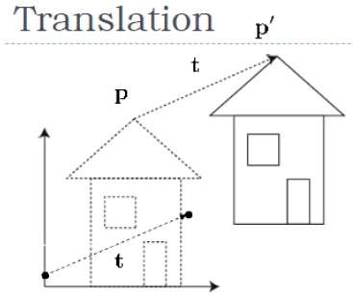

A point can be translated in 3D by adding translation coordinate (tx,ty,tz)(tx,ty,tz) to the original coordinate (X, Y, Z) to get the new coordinate (X’, Y’, Z’).

X 1 0 tx X x+ty

Y = 0 1 ty Y = y+ty

1 0 0 1 1 1

Or P’=T\_.P

T\_ = 1 0 tx

wher 0 1 ty is the translation matrix

0 0 1

Scaling:-

You can change the size of an object using scaling transformation. In the scaling process, you either expand or compress the dimensions of the object. Scaling can be achieved by multiplying the original coordinates of the object with the scaling factor to get the desired result. The following figure shows the effect of 3D scaling −

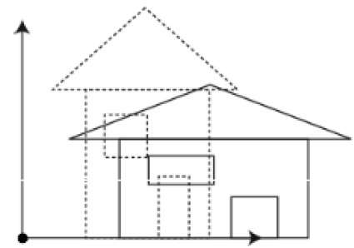

In 3D scaling operation, three coordinates are used. Let us assume that the original coordinates are (X, Y, Z), scaling factors are (SX,SY,Sz)(SX,SY,Sz) respectively, and the produced coordinates are (X’, Y’, Z’). This can be mathematically represented as shown below

Sx 0 0 0

S= 0 Sy 0 0

0 0 Sz 0

0 0 0 1

P’ =P.S Sx 0 0 0

X’ Y’ Z’ 1 = X Y Z 1 0 Sy 0 0

1. 0 Sz 0

0 0 0 1

Q.3 Differentiate parallel projection from perspective projection.

Ans. Parallel Projection:-

1. The center of projection is at Infinite distance from the projection plane.
2. To define parallel projection we specify the direction of projection.
3. The scale and shape of an object is preserved there can be different constant foreshortening along each axis.
4. Projections are parallel.
5. Parallel projecting are categorized by the relation between the direction of projection and normal to the projection plane.
6. Parallel projection is a less realistic view because perspective foreshortening is lacking.
7. It is used by drafter’s and organizers to create drawing of an object which preserves its scale and shape.

Perspective Projection:-

1. The center of projection is at a finite distance.
2. To define perspective projection, we explicitly specify the center of projection.
3. The size of the projection of an object varies inversely with the distance of that object from the center of projection.
4. The lines of projection or projection are converges to a point that is, lines of projection appears to meet at point on the view plane called vanishing point.
5. Perspective projecting are categorized by their number of principle vanishing points and by the number of axis the projection plane cuts.
6. Perspective projection of an object looks realistic, due to perspective foreshortening and vanishing points.
7. The visual effect is similar to that of photographic systems and of the human visual system, this feature is known as perspective foreshorting.

Q4. What are the various 3-D transformations?

Ans. 3-D transformations:-

The ability to represent or display a three-dimensional object is fundamental to the understanding of the shape of that object. Furthermore, the ability to rotate, translate, and project views of that object is also, in many cases, fundamental to the understanding of its shape. Manipulation, viewing, and construction of three-dimensional graphic images require the use of three-dimensional geometric and coordinate transformations. In geometric transformation, the coordinate system is fixed, and the desired transformation of the object is done with respect to the coordinate system. In coordinate transformation, the object is fixed and the desired transformation of the object is done on the coordinate system itself. These transformations are formed by composing the basic transformations of translation, scaling, and rotation. Each of these transformations can be represented as a matrix transformation. This permits more complex transformations to be built up by use of matrix multiplication or concatenation. We can construct the complex objects/pictures, by instant transformations. In order to represent all these transformations, we need to use homogeneous coordinates.

Transformation for 3-D Translation

## Translation:-

In 3D translation, we transfer the Z coordinate along with the X and Y coordinates. The process for translation in 3D is similar to 2D translation. A translation moves an object into a different position on the screen.

The following figure shows the effect of translation –



A point can be translated in 3D by adding translation coordinate (tx,ty,tz) (tx,ty,tz) to the original coordinate (X, Y, Z) to get the new coordinate (X’, Y’, Z’).

X 1 0 tx X x+ty

Y = 0 1 ty Y = y+ty

1 0 0 1 1 1

Or P’=T\_.P

T\_ = 1 0 tx

where 0 1 ty is the translation matrix

0 0 1

Scaling:-

You can change the size of an object using scaling transformation. In the scaling process, you either expand or compress the dimensions of the object. Scaling can be achieved by multiplying the original coordinates of the object with the scaling factor to get the desired result. The following figure shows the effect of 3D scaling −



In 3D scaling operation, three coordinates are used. Let us assume that the original coordinates are (X, Y, Z), scaling factors are (SX,SY,Sz)(SX,SY,Sz) respectively, and the produced coordinates are (X’, Y’, Z’). This can be mathematically represented as shown below

Sx 0 0 0

S= 0 Sy 0 0

0 0 Sz 0

0 0 0 1

P’ =P.S

Sx 0 0 0

X’ Y’ Z’ 1 = X Y Z 1 0 Sy 0 0

0 0 Sz 0

1. 0 0 1

Rotation:-

3D rotation is not same as 2D rotation. In 3D rotation, we have to specify the angle of rotation along with the axis of rotation. We can perform 3D rotation about X, Y, and Z axes. They are represented in the matrix form as below –

1 0 0 0 cosθ 0 sinθ 0

1. cosθ −sinθ 0 0 1 0 0

Rx(θ)= 0 sinθ cosθ 1 Ry (θ)= −sinθ 0 cosθ 0

0 0 0 1 0 0 0 1

Cosθ −sinθ 0 0

Rz(θ) = sinθ cosθ 0 0

0 0 1 0

0 0 0 0

The following figure explains the rotation about various axes −

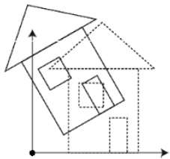

Shearing:-

A transformation that slants the shape of an object is called the shearing transformation. Like in 2D shear, we can shear an object along the X-axis, Y-axis, or Z-axis in 3D.

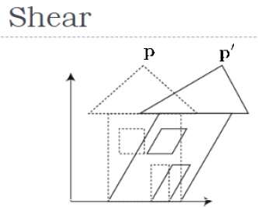

As shown in the above figure, there is a coordinate P. You can shear it to get a new coordinate P', which can be represented in 3D matrix form as below −

X’ 1 Shx 0 X

Y’ = 0 1 0 Y

1 0 0 1 1

P’=SHshx .P

1 Shx tx

Where SHshx = 0 1 0 is the translation matrix

0 0 1

Reflection:-

he operation of exchanging all points of a mathematical object with their [mirror images](http://mathworld.wolfram.com/MirrorImage.html) (i.e., reflections in a mirror). Objects that do not change [handedness](http://mathworld.wolfram.com/Handedness.html) under reflection are said to be [amphichiral](http://mathworld.wolfram.com/Amphichiral.html); those that do are said to be[chiral](http://mathworld.wolfram.com/Chiral.html).

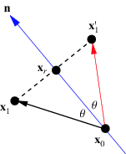

Consider the geometry of the left figure in which a point x_1 is reflected *in* a mirror (blue line). Then

|  |
| --- |
| x_r=x_0+n^^[(x_1-x_0)·n^^], |

so the reflection of x_1 is given by

|  |  |
| --- | --- |
| x_1^'=-x_1+2x_0+2n^^[(x_1-x_0)·n^^]. |  |

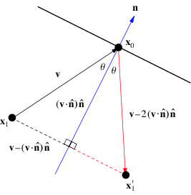

The term reflection can also refer to the reflection of a ball, ray of light, etc. *off* a flat surface. As shown in the right diagram above, the reflection of points x_1 off a wall with [normal vector](http://mathworld.wolfram.com/NormalVector.html) n satisfies

|  |  |
| --- | --- |
| x_1^'-x_0=v-2(v·n^^)n^^. |  |

If the [plane](http://mathworld.wolfram.com/Plane.html) of reflection is taken as the yz-[plane](http://mathworld.wolfram.com/Plane.html), the reflection in two- or three-dimensional [space](http://mathworld.wolfram.com/Space.html) consists of making the transformation x->-x for each point. Consider an arbitrary point x_0 and a [plane](http://mathworld.wolfram.com/Plane.html) specified by the equation

|  |  |
| --- | --- |
| ax+by+cz+d=0. |  |

Q.6 Write notes on 3D viewing transformations and clipping?

Ans. 3-D viewing transformations:-

In 2-d graphics application, viewing operations transform projection from would coordinate systems. Plane is pixel positions in the plane of the output device. In 3-d we can view an object from any position i.e. top, front and box or we can view an object according to our own choice, id we are standing is are middle or inside the object in 2-d view we can easily transformed would coordinate system into device coordinate system. But in 3-d, it is more complicated in this before transformation the object into device coordinate system, the object is needed to be projected, in short in 3-d transformations projection is used.

Ex:- Suppose the viewer is in airplane and his can be of projection(eye) can move anywhere ground or above the ground, cooking in any direction and projection plane (view plane) can also be forcing in any direction.

3-D CLIPPING:-

As parts of an object that our outside the view volume are discarded. Instead of clipping against straight line window boundaries, We now clip object against the boundaries plane of view volume (front, back, about)Just like the case in two dimensions, clipping removes objects that will not be visible from the scene The point of this is to remove computational effort

3-D clipping is achieved in two basic steps:-

Discard objects that can’t be viewed i.e. objects that are behind the camera, outside the field of view, or too faraway

Clip objects that intersect with any clipping plane

Clipping Strategies

Because of the extraordinary computational effort required, two types of clipping strategies are followed:

Direct Clipping:

 The clipping is done directly against the

view volume.

Canonical Clipping:

 Normalization transformations are applied which transform the original view volume into normalized (canonical) view volume. Clipping is then

 Performed against canonical view volume.

\*\*\*\*\*\*\*\*\*\*\*\*\*\*\*\*\*